Hong Kong Institute of Vocational Education

Discipline of Information Technology

ITE4116M

Final Year Project

Project Guide

Introduction

Final Year Project is a key module in the programme, and is mandatory to all final year students. This module is centered on a single project, chosen by a group of students, which solves a real-life problem using contemporary technologies. The module provides the opportunity for students to link materials from different modules and to reinforce the knowledge gained from the course in previous semesters. Students can further develop their problem-solving abilities and to follow up, in detail, an area of their own interest through the module.

Each student is expected to put in substantial effort in the project. Through active participation in project work, students will be equipped with the abilities in problem identification, the experience in literature searching for knowledge acquisition, the skills in solution formation for the problem based on understanding about the problem, the knowledge for working out the methodology to implement the formed solution, and the hand-on experience in implementing the solution. In addition, good project management is essential to the success of the project. Students are requested to achieve the expected goals (in quality and scope) under the existing constraints (especially in time and resources).

Students should investigate possible solutions to their selected problem and develop a plan for the implementation of an environmental friendly solution. Students should also explore the possibility to develop a bilingual or cross-border deployable system to meet Greater China business needs. Also, students are required to develop their project professionally and ethically and according to the codes of conduct of leading professional bodies of related disciplines.

Learning Outcomes

Through active participation in project and completion of the project, a student should be able to:

- research on a reasonably complex business or technical problem and propose a possible solution in the area of information technology
- develop a project development plan, and monitor and report their project progress
- analyze, design, implement, and test a proposed solution
- work independently and collaboratively with others as a member of a project team
- document and verbally present their work in a professional way

Project Formulation and Development

Project topics will normally be set so that students can work together as a group to collectively develop a solution. Each project team involves 3-4 students. However, each student will have their own assigned roles and responsibilities and their contributions will be individually assessed. The distinguishable responsibilities and works of each student should be clearly specified in the project proposal and progress reports. Marks will be awarded to the members according to their contributions to the project.

The approaches to divide the work of developing a large system:

- data interfaces – divide the system into several subsystems. The subsystems communicate with each other by a database. Issue: must agree on a common database.
- programming interfaces – divide the system into several subsystems. The subsystems communicate with each other by calling functions. Issue: must agree on the specifications of functions provided by each subsystem.
- protocol interfaces – divide the system into several subsystems. The subsystems communicate with each other by sending messages. Issue: must agree on the communication protocol.

Project Selection Procedure

- The students form a project group.
- The students think about what they want to achieve to satisfy the objectives of the unit.
- The students discuss the ideas with a lecturer.
- The lecturer agrees to supervise the student. The project group must send an email which includes the member names, group & group numbers and the supervisor name to the project coordinator and the supervisor.
- The students write and submit a project suggestion to the supervisor.
- The students write and submit a project proposal to the supervisor.
- If the proposal is not approved by the supervisor, repeat step 5.
- The proposal is accepted.

Milestones

Sep 1) Project Group Member List sent to the Project Coordinator and Supervisor.
2) Project Suggestion submitted to Supervisor.

- Sep Submit Project Proposal

- Nov Submit Initial Report

- Jan/Feb Submit Interim Report and prepare Oral Presentation covering project plan, requirements, analysis, design, suggested solution and prototype implementation.

- April/May Submit Final Report and prepare Oral Presentation & Demonstration covering requirements, analysis, design, solution, implementation, program listing, user guide, and installation guide.

Industrial or Commercial Based Projects

Projects undertaken in conjunction with industry are encouraged. In such situations, the IVE-based Project Supervisor must be satisfied that the student has adequate supervision and that the assessment process and standard are not compromised.

- Students are encouraged to propose ‘real-world’ projects.
- Students are advised not to promise to deliver any software or documentation to the external organization without the supervisor’s consent. Students may not be able to finish your work according to the deadlines set by the external organization.
- At present, IP rights associated with ‘in-house’ student projects reside with the students, and VTC is automatically sub-licensed to use that IP.
- With external projects, students may generally be required to sign an agreement with the sponsor organization requiring them to relinquish your IP rights. Students should weigh the potential benefits of working on a real industrial project the loss of their IP rights.
- Students may also be asked to sign a Non-Disclosure Agreement form which requires them to protect the confidential information provided by company. Please use the standard Non-Disclosure Agreement Form prepared by the department obtainable from the project coordinator as far as possible.

Project Management

The Final Year Project does provide a precious opportunity for the students to practice and strengthen their knowledge and skills in project management acquired in their previous studies.

The project management skills being in concern are:

- Planning
- Problem handling (ability in solving problems independently)
- Progress management (keeping the decided schedule and appropriate modification of the schedule)
- Resources allocation (balanced distribution of effort among different activities)
- Communication among different teams members and parties
- Co-operation of team members

Before actually implementing the solution for the problem, a development schedule should be drafted first, and the students are requested to follow the schedule in a serious manner so as to prevent the students from developing the system in an ad-hoc manner or in rush during the period close to the project submission deadline

Project Review

The students should review the project regularly so as to:

- adjust the development schedule according to the actual situation (for each of such adjustment, description of the cause / issue behind should be logged and presented in the final report)

- allot further details to develop plan of later development activities (the ground supporting such further details should be logged and presented in the final report)

The students should meet their supervisor for 30 minutes every week.

Supervisor and Co-marker

Each project is assigned an overall supervisor and a co-marker to assist with assessment. It is the supervisor’s role to act as a mentor to the student and to guide the planning of the project solution.

Deliverables

Initial Report

In semester 4, students are required to submit an initial report which should cover the analysis work undertaken, requirement specification, initial design and project plan.

The report may include, but not limit to:

- Background information of the problem
- Expected stakeholders of the project
- Assumed users of the completed system
- Exploration of possible solutions
- Overview of the Proposed solution
- Expected scope and limitations of the proposed solution (specification of the system)
- Required resources (hardware and software) for the system development
- Expected deliverables to be generated
- Project schedule:
- Milestone / expected deliverables of each development activity
- Expected completion dates of early development activities
- Task and role of each student
- References

The report must be well-presented.

Interim Assessment

At the beginning of semester 5, students are required to submit an interim report which includes a written submission, an oral presentation and a demonstration of prototype work undertaken. The interim report should cover analysis work, requirement specification, initial design, prototypes, etc. and will be assessed according to the quality of work done so far.

Interim Report

At the middle of the project development, an interim report should be submitted.

The report may include, but not limit to:

- Requirement analysis:
- General descriptions of the existing systems, the intended users, and its relationship to other systems
- General descriptions of all the functions of the system
- High-level diagrams, e.g. systems architecture, context diagrams, etc.
- Data dictionary for the entire user level data
- Requirement specification/Detailed Design:
- Data models and process models being employed in the solution
- Physical configuration of the system under construction
- Function architecture of the system under construction (functions to be provided by each module in the system)
- User interface design
- Problems/difficulties encountered in the due course of system development, and solutions being employed for overcoming the problems / difficulties
- Further details allotted to the initial project plan as described in the initial report
- Deviation of the project progress from the originally proposed schedule, and the causes behind such deviation
- Test plan

Students adopting Object-Oriented methodologies for system analysis and design should provide the following set of UML diagrams and documents in the interim and subsequent reports:
- Requirement analysis:
- Actor descriptions
- Use case diagram
- Initial use case descriptions and base use case descriptions
- Data dictionary
- Requirement specification/Detailed design:
- Class diagram (design level)
- 3-tier sequence diagrams
- State diagrams for control objects of some use case

The report must be well-presented.

Interim Oral Presentation

At the middle of the project development, students are required to give an oral presentation of their progress.

During the presentation, students should at least show the following aspects concerning the project:

- Project background
- Encountered problems and employed solutions for problem solving
- So far completed work
- Expected upcoming progression
- Prototype demonstration
- Insufficient aspects in the completed work, expected improvements in the upcoming development

In addition, students are expected to handle or answer questions concerning the project.

For the presentation, assessment will be based on the following factors:

- Selected material for the presentation
- Preparation for the presentation
- Presentation skill and question handling skill

Progress Report and Mid-Semester Demonstration

To ensure your project is on the right track, you are required to submit a progress report and conduct a mid-semester demonstration to your supervisor at the middle of semester 5.

The progress report should describe what have been achieved during the reporting period and contain a list of outstanding tasks and system functions.

Final Assessment

At the end of semester 5, students are required to submit the final product and a final report that presents and demonstrates the completed project. An oral presentation and a demonstration of the final product is also required.

Final Report & Completed System

At the end of the project development, a final report should be submitted.

The report may include, but not limit to:

- Final design of the system, deviation of the final design from the original design, and the ground for such deviation
- Final version of the test plan
- Test results in each test
- Final version of the project development plan having all details allotted
- Actual progress of the project, deviation of the progress from the schedules as mentioned in previous reports, and causes behind such deviation
- User manual of installation and operation of the completed system
- Critical Evaluation of the Project

The report must be well-presented.

Final Presentation and Demonstration

After the project development period, each project group should have a presentation and demonstration on the completed work.

During the session, the group will have an oral presentation at least on the following aspects:

- Description of the existing problem
- Formed solution for the problem
- Scope and limitation of the solution
- Rooms for further improvement on the completed project / system

The project group should conduct also a demonstration of the completed system, which is used to show the features/functionality of the completed system.

In addition, students are expected to handle or answer questions concerning the project.

For the presentation and demonstration, assessment will be based on the following factors:

- Selected material for the presentation and demonstration
- Preparation for the presentation and demonstration
- Design of the operation flow in the demonstration
- Presentation skill and question handling skill

Project Management Skills and Logbook

Project management skills are assessed according to the management of project work by the student over the whole project period and are based on project logs. Students’ performance will be monitored through regular meetings with their project supervisor. Students will be assessed on their information searching skills, project management skills and effort. They have to keep a log of their activities which can be regularly reviewed. These regular meetings will also serve as the forum to maintain a record of the contribution of individual students to the group project.

Logbook

Each group participating in the Final Year should submit a logbook, which is composed of a number of bi-weekly log-sheets.

Alternate week, each group should fill in a log-sheet with the following entries:

- items completed in the past one week
- to-do list
- findings in background research information (optional)
- list of collected documents and reference materials (optional)
- innovated ideas (optional)
Rationales behind having such a logbook for each group are as the followings

- provide a repository of project data, which facilitates the authoring of reports
- provide background data for further project plan detailing and regular project review
- ensure even progression of the system development and prevent students from working on the project in rush within the period close to the system submission deadline
- prevent existence of free-riders through recording contributions of each student

Assessment

Assessment is staged, in order to provide checkpoints for monitoring progress. There are four assessment components and the weightings are as below:

Assessment Components Weighting
- Initial report 10%
- Interim report 30%
- Final report 50%
- Project management skills 10%

Each student in the project group will be assessed individually on his/her performance in project management skills, oral presentation/demonstration and implementation quality of the subsystem of the final product that the student is responsible for. The initial report will be assessed according to group performance. The written submission of the interim report and the written submission of the final report will be assessed according to group performance and individual contribution. The assessment weighting for collaborated submission is 6:4 in favour of individual contribution (i.e. 60% for individual mark and 40% for group mark). At each stage, a project group has to submit a written statement which indicates the individual contribution of work of each student in the group in that stage. The supervisor and the co-marker will consider these percentages and then determine the weighting given to each student for awarding a staged mark. Mark will be firstly awarded using the same marking scheme for individual projects. The intermediate mark is then redistributed to give the mark of each student in a group according to the following scheme:

- Group mark for each student: marks of the deliverable × 0.4
- Individual mark for a student: marks of the deliverable
where n is the number of students in the group
w_{i} is the weighting given to student i and

3. The mark for a student = group mark for the student + individual mark for the student

The following table summarizes the break-down of group performance and individual contribution in this assessment scheme:

Assessment Components | Weighting | Assessment criteria
Assessment Components | Weighting | Group Performance | Individual Contribution
Initial Report | 10% | 10% | 0%
Interim Report  - Written submission  - Prototype implementation  - Demo and oral presentation | 15%  10%  5% | 6% | 9%  10%  5%
Final Report  - Written submission  - Final Product  - Demo and oral presentation | 15%  30%  5% | 6% | 9%  30%  5%
Student Performance, including information search, management skills, effort etc. | 10% | 0% | 10%
Total: | 100% | 22% | 78%

Annex 1: Project Proposal Guidelines
Hong Kong Institute of Vocational Education
Annex 2: Initial Report Guidelines
Discipline of Information Technology
Final Year Project (ITE4116M)
Project Proposal
The project proposal must be submitted to the Project Coordinator by _______________________.

Please refer to the following guidelines for writing the Project Proposal.

Guidelines for Writing the Project Proposal
The structure and contents of the initial report should include

- Statement of problem to be solved: describe the services provided by the proposed system.

- Background of the problem: describe the environments or domains in which the proposed system will be used.

- Outline of proposed solution:
- Explain what approaches you will use to develop the proposed system. You should explain the issues of the solution, for example, the system architecture, the algorithms (e.g. shortest path algorithm), software architectures (e.g. client-server), development methodology (e.g. Object-oriented approach)
- Define the scope of the proposed system:
- describe all functions to be provided by the system;
- describe data handled by the system;
- describe all non-functional requirements, e.g. performance, usability, software platform, interfaces with existing systems, reliability, etc.;

- Explanation of why proposed solution is appropriate. Explain how your system can meet the requirements of the users.

- Main stages: outline your project plan by describing the system development life cycle with deadlines of tasks.

- Main deliverables: describe the things that you will deliver.

- The responsibilities of each member (required for group project). Explain the allocation of work to individual member.

Hong Kong Institute of Vocational Education
Discipline of Information Technology
Final Year Project (ITE4116M)
Initial Report
The initial report must be submitted to the Project Coordinator by ______________________________.

Please refer to the following guidelines for writing the Initial Report.

Guidelines for Writing the Initial Report
You are expected to look in sufficient detail at the project to be able to plan your work. This will involve preliminary work on the analysis of the problem and even some outlines of the designs. The structure and contents of the initial report should include:
- Abstract: the objectives of the project and a brief description of the contents of the initial report.
- Introduction: a general description of document structure and the project.
- The problem: scope of the problem, description of the problem, description of problem environment.
- Proposed solution: scope of the proposed solution, architecture of the proposed system, functions provided through the proposed solution, data description, role of users and hardware in the solution, advantages and drawbacks of the solution.
- Requirements: reliability requirements, performance requirements, existing data interface and hardware environment, future extensions of the proposed solution, required implementation language.
- Software process model: methodology/approach adopted for developing the solution e.g. waterfall model.
- Project plan: project schedule, deliverables, software tools needed, facilities and hardware needed.
- References.

You may need to adjust the above report structure to suit for your own need.

Annex 3: Interim Report Guidelines

Because it is an early report and will affect the whole direction of the project, it is essential to get it right. For this reason, you must submit a draft one week before the deadline. Your supervisor will look through it and comment constructively in a general way on the draft, but will not give specific guidance or attempt to grade it. You should incorporate this advice into the final version of the report.

Hong Kong Institute of Vocational Education
Discipline of Information Technology
Final Year Project (ITE4116M)
Interim Report and Oral Presentation

You have to submit your interim report on or before _____________________ . The oral presentation will be scheduled in week ___ or week ___.

You may refer to the following guidelines for recording the work you have done at this stage of your project.

Guidelines for Interim Report and Oral Presentation

The interim report consists of two major components: a written submission and an oral presentation including prototype demonstration.

Written Submission

The contents of the Interim Report should cover the following:

- Abstract: The objectives of the project and the interim report.

- Introduction: a general description of document structure, the project and its background.

- The requirements: architecture of the proposed system, scope of the proposed system, description of functions provided and data processed by the system.

- Documentation for problem analysis: Use case descriptions, use case diagrams, class diagram, state transition diagram and sequence diagrams.

- Documentation for detailed design: Data design, software/hardware architectural design (system design) and user interface design.

- Critical Evaluation: any problems/difficulties encountered, any delays/changes in project schedule, limitations of the proposed system, potential difficulties associated with the suggested progression route, etc.

- Detailed project plan

- References

- Appendices
Oral Presentation and Prototype Demonstration
Annex 4: Final Report Guidelines
Each project group is assigned a 40-minute time slot for presentation and prototype demonstration.

The presentation should take no more than 15 minutes and cover no more than 20 slides which may include project objective, problem background, functions provided, some high-level analysis and design diagrams (e.g. system architecture diagram, use case diagram, class diagram, ....), project schedule and summary of progress etc.

After the presentation each student will have 4-5 minutes to demonstrate his/her prototype implementation. You should set up and configure your system properly before the presentation.

The presentation and demonstration must be conducted in English and formal dressing is required.

Staff will consider each of the following points equally in awarding mark:

- Selection of material.
- Preparation.
- Presentation/handling questions.

Requirements of Interim prototype demonstration

The purpose of the interim prototype demonstration is to show the project progress and students' abilities to complete the project.

The demonstration should include
- successful use of core technologies required in the project (e.g. the web client of a 3-tier internet business application should be able to connect to the web server and the database server.)
- implementation of critical/major functions (e.g. the prototype of a mobile surveillance system should be able to show the video/images from the remote cameras)
- UI design (usability, visual and navigation organization etc.). Graphical elements and visual appeal are not important at this stage.

Hong Kong Institute of Vocational Education
Discipline of Information Technology
Final Year Project (ITE4116M)
Final Report
The Final report must be submitted to the Project Coordinator by ______________________________________.

Please refer to the following guidelines for writing the Initial Report.

Guidelines for Final Report

The final report consists of two major components: a written submission and an oral presentation including prototype demonstration.

The written submission

The written submission for the Final Report is a much more formal document than previous reports. At this stage of the programme, the level of presentation and organisation of your reports should be comparable to those in the academic and professional community. Therefore, the guidance on format should be followed exactly, and the details are to be found in Appendix 1. As far as the organisation of the material is concerned, this will depend on a certain extent of the nature of your project. Nevertheless, you should follow the sequence suggested in the next section, and if you want to make any major changes, you should discuss them with your supervisor.

Because the written submission of the Final Report is a main component to understand and assess your project, a poor submission could easily mean that you would fail the component. For this reason, you are asked to submit a draft report to your supervisor about two weeks before the final version is due. Your supervisor will not grade the report nor give you detailed criticism, but he/she will point out whether the report is acceptable, and if not, where you should make improvements.

You should pay attention to the following components in you report:

Structure/documentation/research/literature review/background - for following, and appropriately adapting to, the specifications provided in Appendices D and E and for evidence that you have made some attempt to read around the specific topic of the project.

Problem analysis - for evidence that you have investigated commercially available solutions, analysed the problem, etc. to set your own work in context. You are expected to carry out and document a thorough analysis of the problem and utilise the conclusions of this in your final design/solution.

Design of the solution - for indicating how the solution was developed and also how problems encountered were overcome. This heading covers such aspects like your approach to problem solving, the quality of design, choice of methods, tools and techniques. You are expected to take a 'top-down' approach to the problem and to generate and evaluate different solution options, based on your analysis of the problem, to justify their final choice. The report should not contain full details of the alternatives, but sufficient to show that you are aware that there are usually several different ways to achieve any particular goal and that each of these may have advantages and disadvantages. The chosen method of solution should be fully documented and presented in a clear and well-structured manner. The solution should be complete, even though any implementation may only be partial, for reasons of time or other resource issues.

Quality of implementation - for the quality of the implementation of the chosen solution. The implementation must match with the user requirements and the design of solution. If the project involves software development, this focuses on programming style, techniques used etc. For other types of problems, the criteria may vary.

Testing - for the quality of the test plan, data and results - the detailed content will clearly depend on the type of project carried out.

Critical evaluation of the work - for a critical discussion of all aspects of the project, from whether the original problem formulation was correct, to how well the solution meets the specification.

It is important to realise that marks are given for quality, not quantity; the length of each section should be appropriate to the nature of the problem, and the amount of work which you have done in that area. This is also true for the whole report. Because of this, it is difficult to provide a guideline for the length of a report. For a typical project group of three members, the length of the final report should be 8,000 - 10,000 words (excluding tables, figures, listing etc.).

The following is the suggested structure of the final report:

Title page

Abstract: the objectives of the project and the final report.

Acknowledgement

Table of Contents

List of Tables and Figures

Introduction: a general description of document structure, the project and its background.

The requirements: architecture of the proposed system, scope of the proposed system, description of functions provided and data processed by the system, other non-functional requirements, such as interface with existing system(s).

Documentation for problem analysis: data model (e.g. ERD or class diagram), functional model (e.g. DFD + process description or use cases + use case descriptions), dynamic model (e.g. control flow diagram + state transition diagram, sequence diagram + object collaboration diagram), data dictionary.

Documentation for detailed design: data design, software/hardware architectural design (system design), procedural design (module), user interface design.

Implementation: record of the implementation work, e.g. test plan, test results, changes to design and justification of changes. The implementation documentation should include the user guide and installation guide which are submitted in a separated volume.

Results and conclusions: a summary and a critical discussion of the results, conclusions, any problems/difficulties encountered, any delays/changes in project schedule, limitations of the proposed system, and in some cases a subsection suggesting further developments to be undertaken.

References

Appendices: there must be at least TWO appendices:
- The first must contain the original project plan with segmentation of activities and estimated times for their completion, which you submitted in your Initial Report, together with a revised plan which records how you actually spent the time.
- The second must be copy of your project log book.

Program listing: listing up to 20 pages of source code (code which is written by yourself) can be included in the appendix of the final report and in this case should be produced on A4 paper. If you have substantial program listings these should be submitted in a CD Rom.

User guide and installation guide: a user guide and installation guide for the system submitted in a separate volume.

Please also include the soft copy of the source code and executable code of your program stored in a CD/DVD. Please also include the soft copy of your reports, user guide and installation guide.

Some of the above items may not be relevant to your project. You should adjust the above report structure to suit for your own need, especially your development methodology. You should consult your supervisor and co-marker when you set your own report structure.
Final Report Oral Presentation and Demonstration

Each project group is assigned a 1-hour time slot for presentation and system demonstration. The presentation should take 20 minutes or less and cover no more than 20 slides which can include the project objective, problem background, functions provided, some high-level analysis and design diagrams (max 1 diagram for one kind, e.g. system architecture diagram, use case diagram, class diagram, ....), planned and actual project schedules, testing strategy, final outcome and critical evaluation, etc.

You need to consider the following points for the presentation:
- Selection of material.
- Preparation.
- Presentation/handling questions.

When presenting your work, you will be expected to make use of the handouts, computer files prepared by any presentation software, overhead projector slides etc. as appropriate.

After the presentation each student will have 10 minutes to demonstrate his/her prototype implementation. You should set up and configure your system properly before the presentation. Due to the time constraint, students should think carefully the choice of system functions to be shown and plan the test cases ahead. We suggest each student demonstrate the most important functions and main program routes and record the demonstration of all other secondary functions and alternative program flows on a CD/DVD.

Appendix

Format of the Report

Size and typing: single line or 1.5 lines spacing throughout; A4 white paper; a font size of 12 point for the body text.

Margins: all margins are at least 1 inch, except the left margin, which is 1.5 inches. This is to allow for binding. Spiral binding has to be used.

Page numbering: the pages are numbered consecutively except for the title page. Appendices are numbered separately on each page as A1, A2, B1, B2 etc.

Style of writing: it has become conventional for report writings to refer to oneself in the text as 'the author' rather than 'I' or 'me'. Mis-spelling is irritating - use the spell checker inside the word processor.

Source Materials: extracts and interpretations of other people's work should be identified in the text by either the authors’ name(s) and/or a numeric index; the source of the extract or interpretation should be listed under the section headed References. This section should list all references in alphabetic order of author's surname. The detail must be given to enable the reader to trace the source; hence it must contain the following elements in sequence:

(a) the author's surname followed by his initials (e.g. SMITH, A B).
(b) the date of publication (e.g. 1985)
(c) the title of the work (in italic)
(d) the place of publication (e.g. London)
(e) the name of publishers (e.g. Wiley)
Examples:
- LANGEFORS, B. (1973). Theoretical Analysis of Information System, Philadelphia: Anerbach.
- SALTON, G., YANG, C. S. AND YU, C. T. (1975). A theory of term importance in automatic text analysis, Journal of the American Society for Information Science 26, 33-44.

Organisation: The report must be divided into major sections, each with its own heading, beginning on a fresh page. The appendix has its own main heading, and each appendix is appropriately labelled: 'APPENDIX A', 'APPENDIX B'

Tables and diagrams: should be numbered 'Table 1', 'Figure 1' throughout the text.

Final Year Project - Log Sheet (No. )
Annex 5: Log Sheet

Course/Class: _______________________ | Project ID: _________________________
Supervisor: _________________________ | Date: ______________________________
Project Title: ____________________________________________________________
Student Name(s): _________________________________________________________

Work done & findings since last recording | Logged by
State which part of the last plan not yet finished (leave it blank if you finished all the work of the last plan | Logged by
Plan of work before the next recording | Logged by

Supervisor’s comment on student’s work

Student’s Signature: |  | Supervisor Signature:
Annex 6: Progress Report for Mid-Semester Demonstration
Hong Kong Institute of Vocational Education
Discipline of Information Technology
Final Year Project (ITE4116M)
Progress Report for Mid-Semester Demonstration

Group Number:
Project Title:
Student Name:
Supervisor:
Date:

Tasks/Functions completed and shown successfully in the demonstration:-

Task Number | Task Description | done by  ( student name)

Outstanding tasks/functions to be completed for the project:-

Task Number | Task Description | Priority  (high/medium/low) | to be done by  ( student name)

Signature: _______________________________

_______________________________

________________________________

________________________________

annex 7 Assessment RUBRICS

Assessment rubrics (initial report)

Marking Section \ Classification | 8-10 | 6-8 | 4-6 | 2-4 | 0-2
Problem understanding  1.5% | Very deep insight into the problem and presented as such | Good insight into the problem and presented as such | Appropriate insight into the problem in most aspects | Poor insight into the problem or which demonstrates an inappropriate, inadequate or incomplete response. | Very little work or a body of work which is very severely flawed by lack of ability to use the required technologies and/or to present the small amount of work done.
Preparatory work  1% | Excellent preparatory work | Good preparatory work | Some preparatory work has been done | Little preparatory work
Coverage  1.5% | All the aspects of the topic are covered | Most aspects of the topic are covered and probably be incomplete in some relatively minor aspects | Some major aspects of the topic not covered | Only covers a few aspects of the topic
Solution Exploration  1.5% | Generate a large amount of ideas and explore almost all possible solutions to the problems  The ideas and proposed solutions are correctly evaluated | Generate a reasonable range of ideas and possible solutions, with some aspects of the topic or directions not discussed  The ideas and solutions are evaluated with some minor mistakes | Insufficient number of ideas and solutions generated Some mistakes in ideas and solutions evaluation | Only generate a few simple and limited ideas and solutions  Incomplete or incorrect evaluation
Planning  1.5% | The students demonstrate how to proceed with very high quality proposed solution and project plan | The students demonstrate how to proceed with good quality proposed solution and project plan | Proposed solution is likely to be incomplete and may omit some aspects of the core problem. Project plan lacks details or is inadequate | Unsatisfactory proposed solution. Incomplete project plan.
Presentation  1.5% | The report is impressively presented in an appropriate style and good grammatical standard | The report is well presented in an appropriate style and with a few grammatical mistakes | The report is structured in a reasonable way and contains some grammatical/spelling mistakes | The report shows a lack of structure, comprehensibility, clarity and grammatical quality
Student Performance  1.5% | Extensive and thorough information search, outstanding planning skills and great effort | Good information search, planning skills and great effort | Displays an adequate level of information search, planning skills and effort | Insufficient information search, poor planning skills and little effort

Assessment rubrics (interim report)

Marking Section \ Classification | 8-10 | 6-8 | 4-6 | 2-4 | 0-2
Analysis  3% | Very deep and thorough analysis and has excellent creativity, clarity, conciseness, and coverage | Good analysis with decent creativity, clarity, conciseness, and coverage | Adequate analysis work with satisfactory level of creativity, clarity, conciseness, and coverage | Poor analysis work with inadequate level of creativity, clarity, conciseness, and coverage | Very little work or a body of work which is very severely flawed by lack of ability to use the required technologies and/or to present the small amount of work done.
Detailed design  6% | Excellent solution design in terms of completeness, correctness,  clarity, modularity, flexibility and complexity | Good solution design in terms of completeness, correctness,  clarity, modularity, flexibility and complexity | Satisfactory solution design in terms of completeness, correctness,  clarity, modularity, flexibility and complexity | Poor solution design which demonstrates an inappropriate, inadequate or incomplete response to the problem.
User-interface design  2% | Outstanding user friendly design and appeal | Good user friendly design and appeal | Some flaws but overall user-interface design is adequate | Unsatisfactory user-interface design
Critical Evaluation and Project Plan  2% | In-depth and outstanding critical evaluation and high quality project plan. | Good critical evaluation and project plan. | Some major aspects are not evaluated or the evaluation is incomplete/inadequate.  Project plan lacks details or is inadequate | Unsatisfactory critical evaluation. Incomplete project plan.
Report Writing  2% | The report is impressively presented in an appropriate style and good grammatical standard | They report is well presented in an appropriate style and with a few grammatical mistakes | The report is structured in a reasonable way and contains some grammatical/spelling mistakes | The report shows a lack of structure, comprehensibility, clarity and grammatical quality
Quality of prototype implementation  10% | Core technologies required by the project are successfully used and critical/major functions are extremely well implemented. | Core technologies required by the project are well used and critical/major functions are well implemented. | Use of core technologies is incomplete in some aspects, and critical/major functions are not well implemented. | Implementation of critical/major functions is probably drastically incomplete, severely misguided or severely hampered by inability to use the core technologies required
Presentation  3% | Outstanding skills in selecting material, preparation, presentation and question handling | Good skills in selecting material, preparation, presentation and question handling | Average skills in selecting material, preparation, presentation and question handling | Poor skills in selecting material, preparation, presentation and question handling
Demonstration  2% | Outstanding skills in System setup, operation flow design, demonstration and question handling | Good skills in System setup, operation flow design, demonstration and question handling | Average skills in System setup, operation flow design, demonstration and question handling | Poor skills in System setup, operation flow design, demonstration and question handling

Assessment rubrics (final report and project Management)

Marking Section \ Classification | 8-10 | 6-8 | 4-6 | 2-4 | 0-2
Report (Written Submission)  12% | Excellent work in structure/report writing, problem analysis, design of solution, testing and critical evaluation | Good work in structure/report writing, problem analysis, design of solution, testing and critical evaluation | Satisfactory work in structure/report writing, problem analysis, design of solution, testing and critical evaluation | Poor work in structure/report writing, problem analysis, design of solution, testing and critical evaluation | Very little work or a body of work which is very severely flawed by lack of ability to use the required technologies and/or to present the small amount of work done.
Implementation -  Level of Difficulty  7% | The implementation is challenging and beyond most students' capabilities, may involve new technologies requiring excessive research work, exploration or testing. | Large system scope and complicated requirements/ involving real user of demanding or unclear requirements/  using new technologies requiring reasonable effort to manage | Medium size project scope and user requirements/  no real user /  required skills already developed in other modules | Simple system with few functions and components
Implementation -  Completeness and correctness  13% | Implementation components are extremely well finished and more than completely fulfill the functional requirements. | Implementation components are well finished and fulfill most of the major functional requirements. | Implementation components are probably incomplete in some  aspects, and may omit some of the more advanced  pieces of work | Implementation is probably drastically incomplete or severely misguided or severely hampered by inability to use the technologies required
Implementation -  User Interface Design  6% | Excellent user interface.  Robust operation of the application, with good recovery. | Good user interface  Consideration given to unusual conditions with reasonable recovery. | Functional but rough user interface.  Some attempt at detecting and correcting errors. | Poor/confusing user interface.  Little or no error detection or correction.
Testing  3% | Very structured test plan with all possible scenarios are covered by test cases  Correct result in each test | Good test plan with a few scenarios not considered  Almost all tests are correct | Incomplete test plan with some major test path not covered  Fail in some tests | Poor test plan  Only some trivial test cases are set and tested
Mid-semester Demonstration  4% | Excellent system implementation and meeting the schedule | Good system implementation and/or no/a little behind schedule | Satisfactory system implementation and/or some delay in schedule | Poor system implementation and/or noticeably delay in schedule
Presentation  3% | Outstanding skills in selecting material, preparation, presentation and question handling | Good skills in selecting material, preparation, presentation and question handling | Average skills in selecting material, preparation, presentation and question handling | Poor skills in selecting material, preparation, presentation and question handling
Demonstration  2% | Outstanding skills in System setup, operation flow design, demonstration and question handling | Good skills in System setup, operation flow design, demonstration and question handling | Average skills in System setup, operation flow design, demonstration and question handling | Poor skills in System setup, operation flow design, demonstration and question handling
Project Management  10% | Approach the project in a very well organised and well motivated manner. Outstanding skills in planning, problem handling, resources allocation and teamwork. | Approach the project in an organised and motivated manner. Good skills in planning, problem handling, resources allocation and teamwork. | Approach the project as a whole in an organised manner.  Average skills in planning, problem handling, resources allocation and teamwork. | Approach the project in a disorganised manner. Poor skills in planning, problem handling, resources allocation and teamwork.

annex 8A mark sheet for initial report (Sample Format)

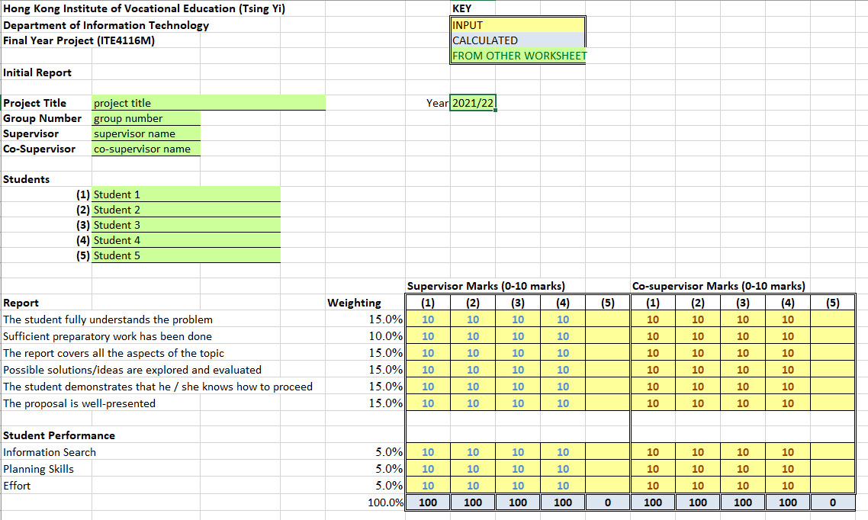
annex 8B mark sheet for interim report (Sample Format)

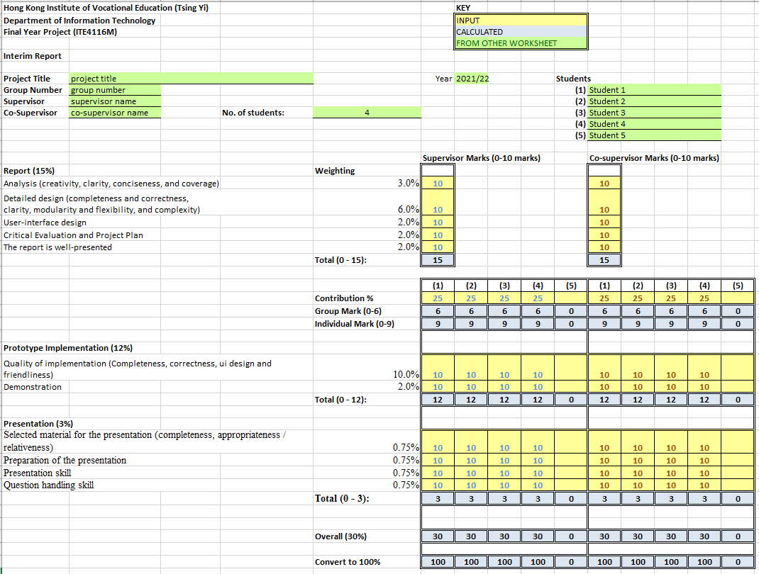
annex 8C mark sheet for final report and project management (Sample Format)

